Tool usage and task assignment
1. Utilized the Requests library to fetch the VietQR API and the Pillow (PIL) library to process and display dynamic QR codes on the user interface.
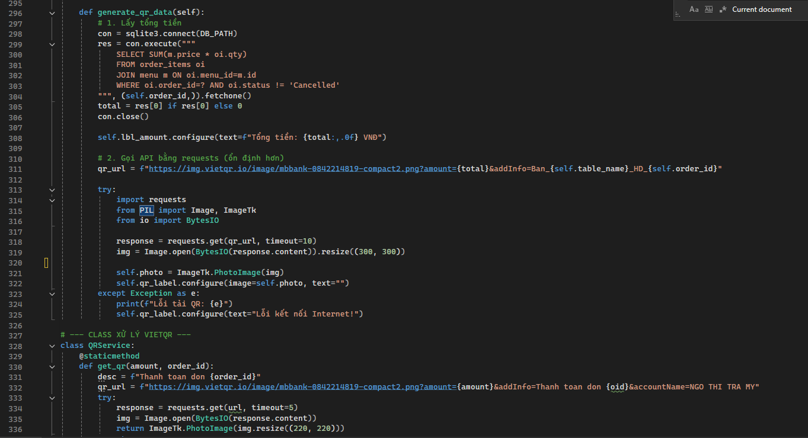
2. Employed Pandas for structured data management and Matplotlib to visualize revenue, as well as best-selling and worst-selling items through graphical charts.
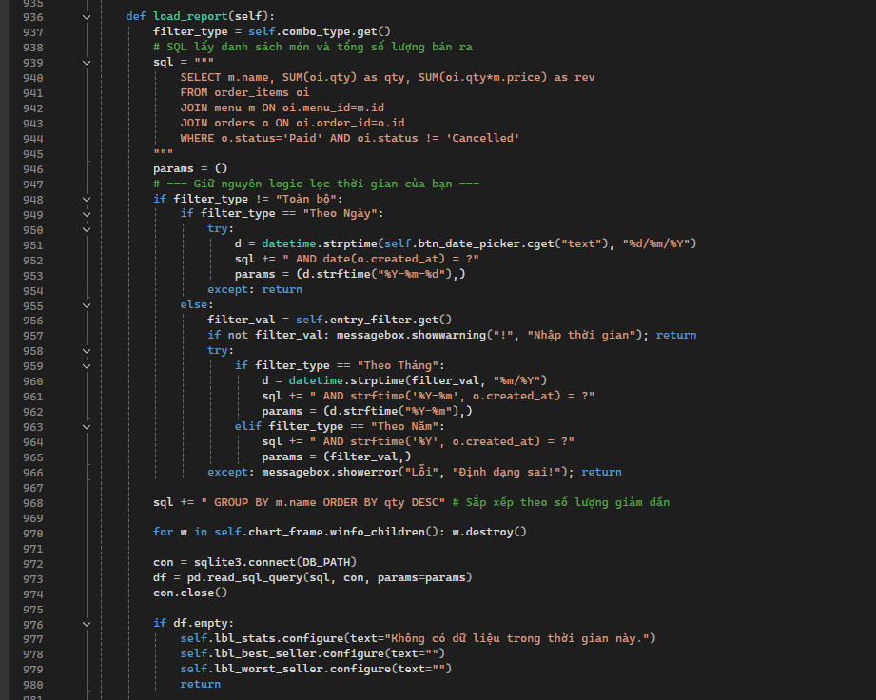
3. Designed and managed a Relational Database Management System (RDBMS) using SQLite3 to store menu items, customer orders, and user account information
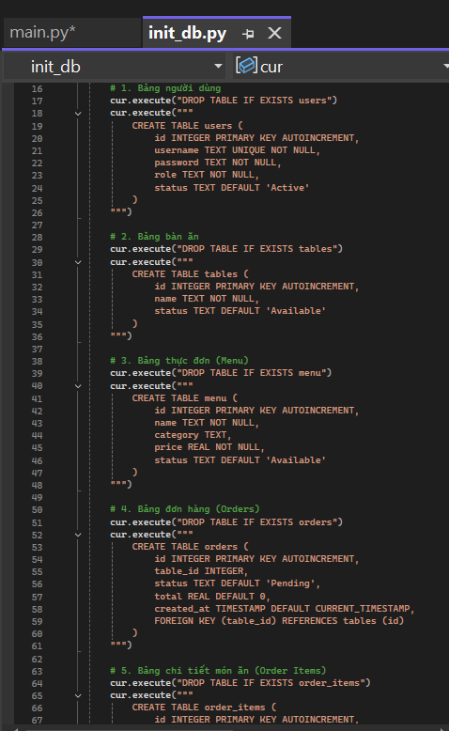
4. Maintained a comprehensive list of supporting Packages installed within the project's development environment to ensure cross-platform compatibility.
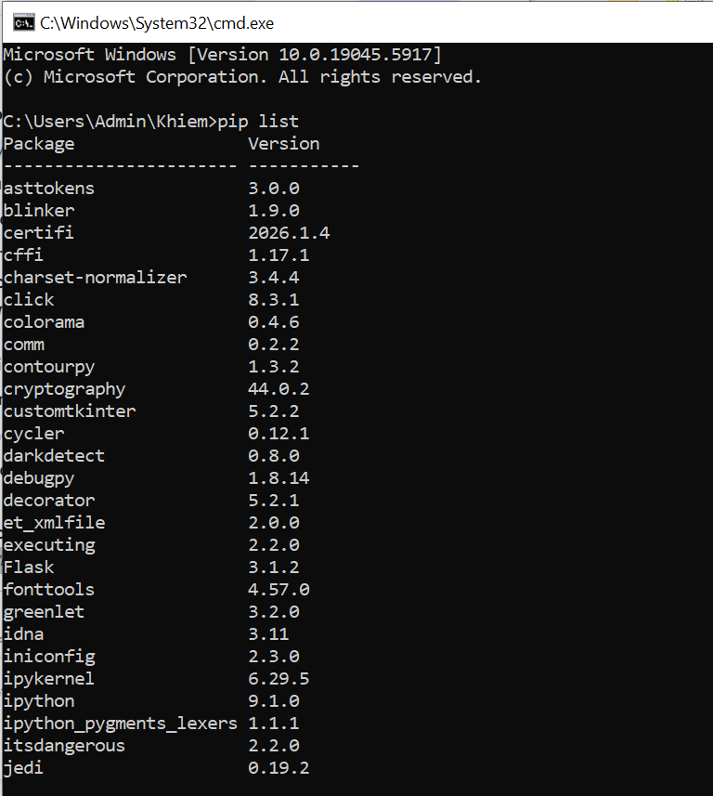
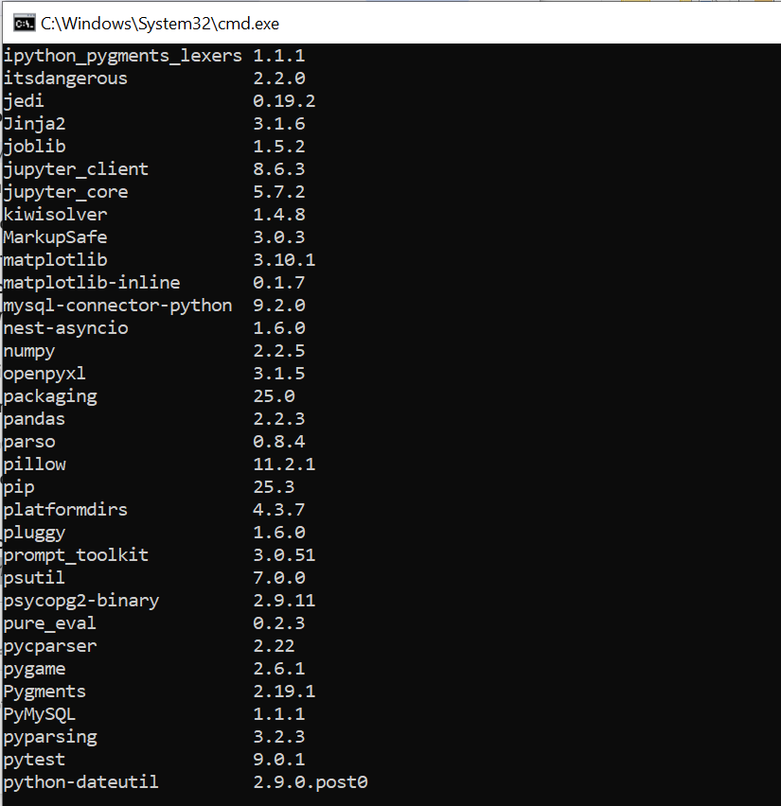
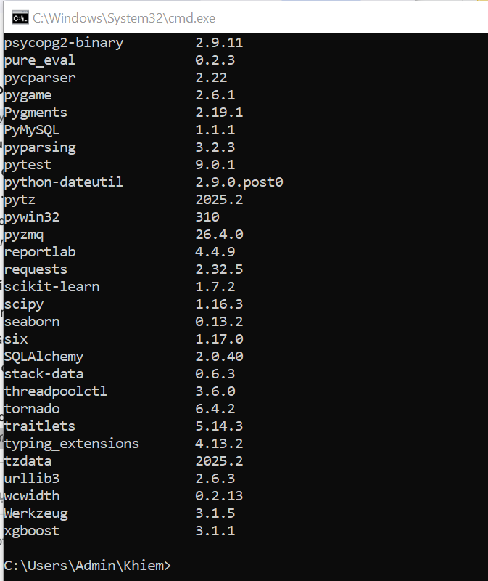

TASK ASSIGNMENT TABLES
Name | Position | Task | Task Progress(%)
Nguyễn Mai Khôi | Leader | Main Interface Developer | 100
Ngô Thị Trà My | Member | Cashier & Payment Module Developer | 100
Nguyễn Thị Ngọc Hân | Member | Reporting & Invoice Export Specialist | 100
Vắn Mỹ Vân | Member | Ordering & Table Management Developer | 100
Nguyễn Xuân Khiêm | Member | Database & Backend Engineer | 100

